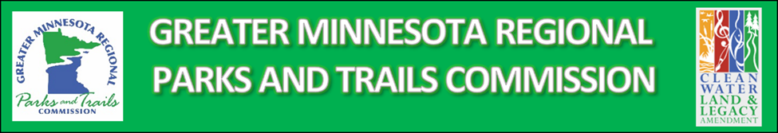
CONNECTING PEOPLE TO THE OUTDOORS GRANT
Greater Minnesota Shared Track Wheelchair Pilot Project
Project Name:
Designated Park/Trail Name:
District:
Applicant Organization (must be a qualified regional designee):
Lead Contact Name:
Lead Contact Title:
Lead Contact Address, Phone, and Email:
Project Partners:

Amount available to grant: $14,280

Attach official agency resolution (template provided)

Project Requirements: Applicant must provide an enclosed facility in which to store the chair and agree to maintain the chair as described by the manufacturer, for a minimum of five years. The applicant must agree to make the chair available for public use at no cost.

During the first two years of chair ownership the facility must make the chair available to designated Greater Minnesota facilities, on mutually agreeable dates, for testing purposes, availability not to exceed 45 days per year. The facility borrowing the chair will be responsible for transportation to and from the owner facility, insurance, as well as maintenance or repairs while in their care.

Answer the following application questions within this Word document and submit
1. How will chair availability be promoted and managed for both your local users and to other facilities in the Greater Minnesota System?
2. Describe your management/maintenance plan for the equipment.
3. Greater Minnesota Legacy Grant Funds Requested/Total Project Cost: $ /$
4. Eligible Local Matching Funds, with source: $

Complete Funding Request Breakdown (Add rows as necessary; Additional detail may be attached):
Eligible Item Details | Item Cost
Track Chair | $14,780 + tax
Item 2 | $
Item 3 | $
Total Eligible Project Cost: | $
Other Ineligible Item Details
Item x | $
Item y | $

Submit by December 9, 2022 to System Plan Coordinator Joe Czapiewski at coordinator@gmrptcommission.org.

