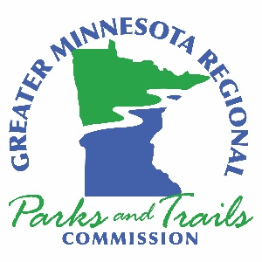

Greater Minnesota Regional Parks and Trail Commission – Agenda
January 26, 2022
10:00am – 3:00pm
Sartell Community Center – Maker Space Room
850 19th Street South, Sartell, MN 56377
DRAFT – January 17, 2022

- Call to Order – Chair Anderson
Meeting goals
- Acknowledge Members of the Public in Attendance
- Approval of Agenda for January 26, 2022, Minutes from November 24, 2021 and Treasurer’s Report through December 2021
- Streetlight Research Project – Raven McKnight, Project Data Scientist DISCUSSION (1 Hour)
Lunch Break – Lunch Provided
- Executive Director’s Report
  - Policy and Planning Report for 2021
  - Mountain Bike Count and User Survey
- System Plan Coordinator’s Report
6.1 Jillian Reiner Consulting Agreement
- Items from Members and Letters to the Commission
- New Business:
8.1 North Country Trail – potential application DISCUSSION (45 Minutes)
8.2 Funding Criteria Update – committee work ACTION (1 Hour)
8.3 Review of 2022 Meeting Locations/PTLAC Meeting Dates DISCUSSION (30 Minutes)
9. Old Business
10. Approval of December 2021 and January 2022 Expenses

Next Meeting and Agenda Items
No meeting in February, next meeting March 23, Austin Jay C. Hormel Nature Center

The Commission “is created to undertake system planning and provide recommendations to the legislature for grants funded by the parks and trails fund to counties and cities outside of the
seven-county metropolitan area for parks and trails of regional significance”

