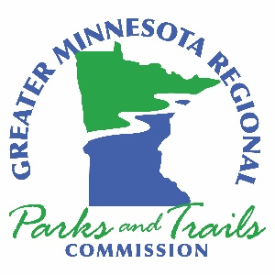

Greater Minnesota Regional Parks and Trail Commission – Agenda
September 22, 2021
10:00am – 3:00pm
Virtual Meeting on Zoom
DRAFT – September 13, 2021

- Call to Order – Chair Ryan
Meeting goals
- Acknowledge Members of the Public in Attendance
- Approval of Agenda for September 22, 2021, Minutes from August 25, 2021 and Treasurer’s Report through August 2021
- Executive Director’s Report
- System Plan Coordinator’s Report
- Items from Members and Letters to the Commission
- Continued Business:
  - Wright County Funding Application Resolution – Commissioner Wendorf
Action (45 Minutes)
- New Business:
  - Jon Oyanagi Presentation Part II Diversity Training Discussion (1.5 Hours)
  - Strategic Planning Review Discussion (1 Hour)
- Staffing
- Evaluation Team Interaction – Planning for October Meeting
- Tribal Liaison/Outreach
- Old Business:
9.1 Review of FY23 Funding Applications – Commissioner Questions Discussion (1 Hour)
- Approval of August Expenses
- Next Meeting and Agenda Items
October 27, Granite Falls Kilowatt Community Center
The Commission “is created to undertake system planning and provide recommendations to the legislature for grants funded by the parks and trails fund to counties and cities outside of the
seven-county metropolitan area for parks and trails of regional significance”.

