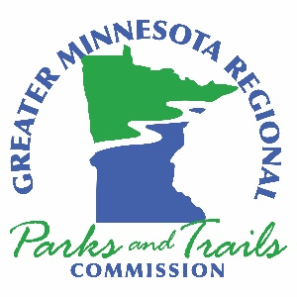

Greater Minnesota Regional Parks and Trail Commission – Agenda
November 24, 2021
10:00am – 3:00pm
Virtual
DRAFT – November 21, 2021

- Call to Order – Chair Ryan
Meeting goals
- Acknowledge Members of the Public in Attendance
- Approval of Agenda for November 24, 2021, Minutes from October 27, 2021 and Treasurer’s Report through October 2021
- Executive Director’s Report
- System Plan Coordinator’s Report
- Items from Members and Letters to the Commission
- Old Business:
7.1 Funding Recommendations for Fiscal Year 2023 ACTION
8. New Business
  - Cannon Valley Trail Resolution 023 ACTION
  - Approval of Parks & Trails Legacy Advisory Committee Members ACTION
- Approval of November Expenses
- Next Meeting and Agenda Items
December 22, 2021, if necessary

The Commission “is created to undertake system planning and provide recommendations to the legislature for grants funded by the parks and trails fund to counties and cities outside of the
seven-county metropolitan area for parks and trails of regional significance”

