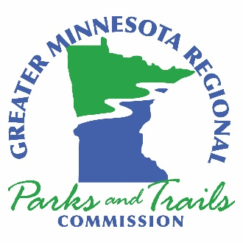

Commissioner addresses for September 22, 2021 Commission Meeting:
District 1
Tim Engrav
Home
7380 Britt Bypass
Britt, MN 55710

Beth Pierce
Mesabi Station
111 Station 44 Road
Eveleth, MN 55734

District 2
Bryan Pike
Home
15872 Jordan Road
Brainerd, MN 56401

Matthew Hill
Crosby City Hall
2 Second Street SW
Crosby, MN 56441

District 3
Peg Furshong
CURE Offices
117 South First Street
Montevideo, MN 56265

Brad Bonk
Douglas County Public Works
526 Willow Drive
Alexandria, MN 56308

District 4
Jonathan Wolf
Rinke Noonan Offices
1015 West St. Germain Street
St. Cloud, MN 56301

Barry Wendorf
Isanti County Government Center
555 18th Avenue SW
Cambridge, MN 55008

District 5
Rick Anderson
Lyon County Courthouse
607 West Main Street
Marshall, MN 56258

Ted Suss
Home
19650 270th Street
Lucan, MN 56255

District 6
Tom Ryan
Home
945 Byron Avenue North
Byron, MN 55920

Tom Stoa
Home
2199 Clinton Drive
Winona, MN 55987

At-Large
Jen Foley
Home
1439 8th Avenue North
St. Cloud, MN 56303

Consultant
Renee Mattson
Home
3601 Trinity Road
Duluth, MN 55811

