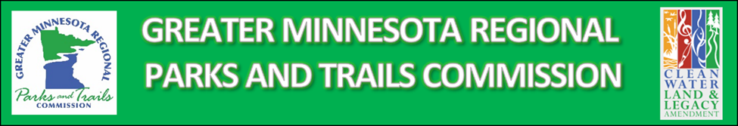
CONNECTING PEOPLE TO THE OUTDOORS SMALL GRANT FUND
FY2023 Project Application

Project Name:
Designated Park/Trail Name:
District:
Applicant Organization (must be a qualified regional designee):
Lead Contact Name:
Lead Contact Title:
Lead Contact Address, Phone, and Email:
Project Partners:

Attach official agency resolution (template provided)

Project Short Description (include how project meets program goals):

Attach preliminary project plan that meets GMRPTC Non-Infrastructure Project Management Policy requirements, particularly “Plans and Outcome Definition” section:
Applications shall include adequate preliminary plans to judge project efficacy… Application details should include detailed maps of the geographic space to be impacted or improved, program or event educational objectives, number/characteristics of people served, clear implementation timelines, program models or best practices used, detailed budgets, long-term sustainability or management plans (encouraged but not required for this grant), and other parameters that help define the outcomes and long lasting impact of the project.

Anticipated number of participants/users involved in/attending project:

Greater Minnesota Legacy Grant Funds Requested: $
Eligible Local Matching Funds (encouraged but not required; with source): $
Total Project Cost: $

Funding Request Breakdown (Add rows as necessary; Additional detail may be attached):
Eligible Item Details | Item Cost
Item 1 | $
Item 2 | $
Item 3 | $
Total Eligible Project Cost: | $
Other Ineligible Item Details
Item x | $
Item y | $

