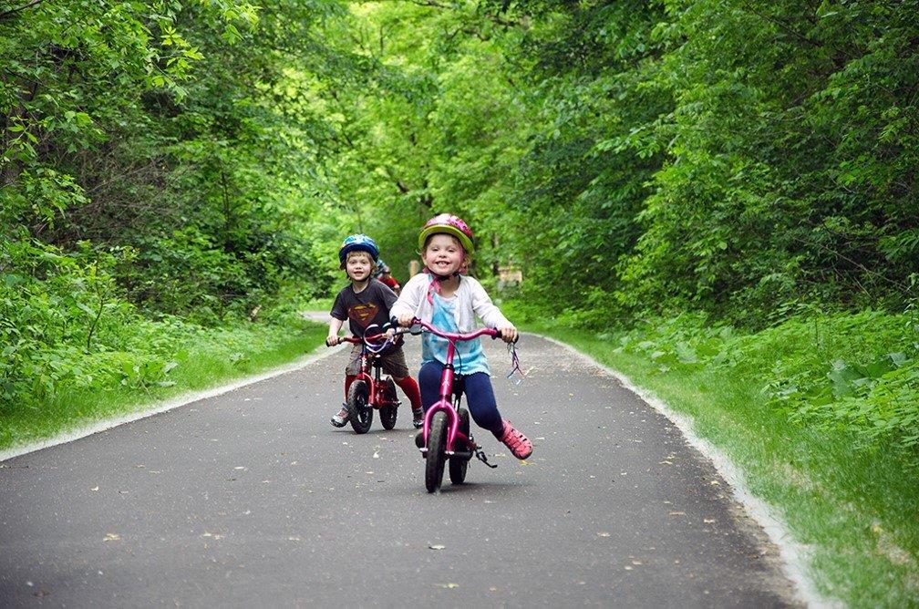  - Friday April 27, 4-7 PM  Parks & Trails Legacy Celebration Event!  What’s Your Legacy?  Thanks to the Clean Water, Land and Legacy Amendment, you help protect and enhance public lands across our state every time you make a purchase! Come celebrate the Amendment’s 10-year milestone on a day filled with all ages, all abilities inclusive activities!  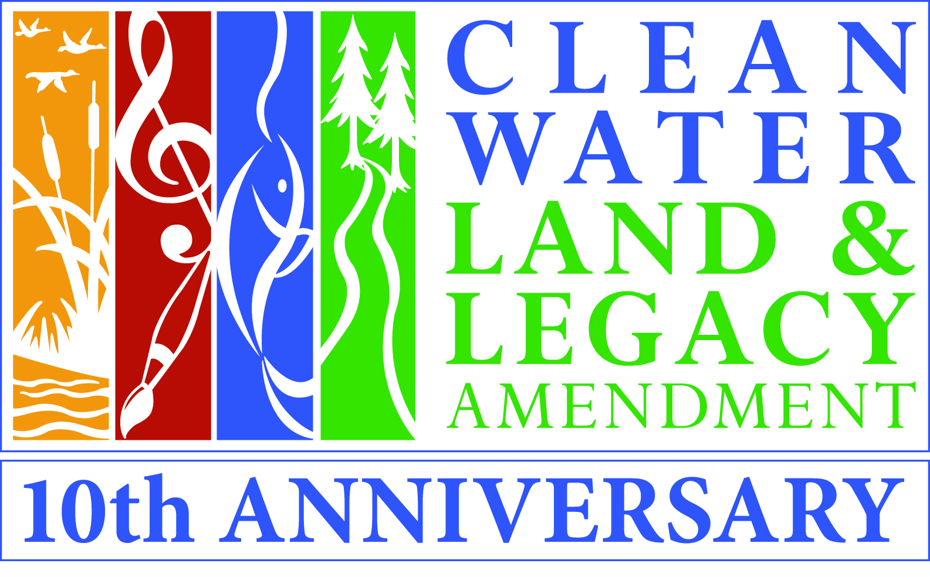  To request accommodation contact Paul Purman at least ten days in advance at paul.purman@state.mn.us or (651) 259-5643. | Learn about Legacy Funded Projects in your area!  ____  Share your thoughts!  ____  Rock Climbing, Biking, ATV Simulator, and More!  ____  Free Family Fun Event!  ____  Sponsored by:  -Parks and Trails Legacy Advisory Committee -Metropolitan Council  -MN Department of Natural Resources  -Greater Minnesota Regional Parks and Trails Commission  St. John’s University Guild Hall  2850 Abbey Plaza  Collegeville, MN 56321  Follow us at: facebook.com/PTLegacyMN/  www.legacy.leg.mn

