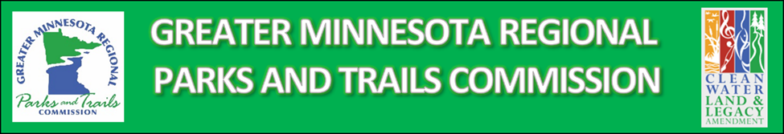
Connecting People To The Outdoors Shared Track Wheelchair Grant Information

At the conclusion of the GMRPTC CPO Small Grant Fund application and awards for 2022 there remains a balance of $14,280 in the CPO fund.

The Commission has made the fund balance available for designated Greater Minnesota facilities to apply for a grant specifically for a track wheelchair.

A successful applicant must demonstrate the ability to store the chair in an enclosed facility, agree to perform maintenance on the chair as recommended by the manufacturer and make the chair available for loan to other designated facilities to test for a period of two years. (Not to exceed 45 days per year, transportation to and from the loaning facility is the responsibility of the testing facility)

A successful applicant must also agree the chair is made available for use at no cost to users.

This project is intended to serve as a prototype, thus the necessity of loaning the chair to other facilities.

Liability release waivers for use of the chair are the responsibility of the grantee.

The Commission has worked with Action Manufacturing/Midwest Trackchair to provide a discounted price for the chair, $14,780 + tax, making the purchase more affordable. The chair will come equipped with the most requested options; attendant control, attendant control relocation mount, cup holder and rod holder. Project costs beyond the available grant funds are the responsibility of the applicant and must be detailed in the application.

Applicants must complete the application and submit by December 9, 2022

